
Managed IT Services
Support Proposal

March 21, 2025
Kelsie Armstrong
Kurt Rahner, CTO
591 Collaboration Way, Suite 603
Newark DE 19713
March 21, 2025
Dear Mr. Rahner,
Arraya Solutions is honored to submit this Managed IT Services Support Proposal to The Kendal Corporation. Enclosed is our official response to the Request for Proposal issued by TKC and all Kendal Affiliates.
Arraya is committed to delivering a seamless and efficient solution that aligns with Kendal’s mission to create and support an environment for community members, board, staff, and volunteers that is welcoming to all cultures, backgrounds, and differences — an environment that promotes mutual respect, acceptance, cooperation, and teamwork. We propose a comprehensive approach service summary that delivers the following outcomes:
Operational Efficiency: Arraya Solutions has 25 years of experience implementing innovative technologies and streamlining processes. We provide a robust service desk and NOC for support, utilize enterprise-class tools to ensure reliable patch application, maintain remote access to limit exposure, and document a knowledge base for operational procedures and schedules.
Flexible Cost Models: Our proposal is structured to ensure that the cost models are presented clearly with Kendal’s business outcomes top of focus. This shared investment model incentivizes both parties to find innovative ways to reduce expenses without compromising quality.
Strong Partnership: Our solution focuses on outcomes that matter most to Kendal, such as improving processes and procedures and tracking KPIs, while keeping service level commitments top of mind. We are confident in our ability to deliver results that benefit your business operations and set you up for future success.
A partnership with Arraya Solutions represents a strategic alliance that drives innovation, efficiency, and cost savings. It is a testament to our shared vision of delivering exceptional service to Kendal. We are eager to embark on this journey together and look forward to the positive impact it will have on your business operations. Thank you for the opportunity.

Warm Regards,
Shawn Reber
Account Executive
SReber@arrayasolutions.com
610.203.2529

Table of Contents
Company History 4
Executive Summary 4
Background 4
Arraya’s Solution 5
Service Desk Support 5
Security Operations Center (SOC) Support 7
Alert & Monitoring as a Service (AMaaS) 9
Lifecycle Management as a Service (LMaaS) 10
Implementation Plan 13
Consulting Services 13
IT Management Policy & Procedure Support 13
Evaluating Performance 14
IT Strategy & Advisory 15
Account Management 15
Service Level Management 15
Service Definitions 16
Service Level Objectives 16
Our Approach 17
Our Pricing 17
Onboarding Fees 19
Fee Consistency 19
Additional Support 20
Firm Qualifications Company Profile 20
MSP Experience Including Nonprofit 20
Transfer of Services 21
Key Personnel & Staff Continuity 22
References 24

Company History
Arraya Solutions is a global IT consulting and managed services provider (MSP) that has been delivering technology solutions to our customers for over 25 years. Our technology focus areas are Network Solutions, Hybrid Infrastructure, Cybersecurity, Modern Workplace, and Application/AI Development. We offer IT solutions, advisory, consulting, staffing, Cloud Solution Provider (CSP), and managed services, and maintain partnerships with industry-leading OEM vendors and service providers. Our mission is to collaborate with each customer to develop solutions for their unique needs. Arraya delivers the intelligence, tools, and resources companies need to rise to the top of their field.
Arraya Solutions is recognized as an Elite Managed Services Provider, named to CRN’s Managed Service Provider (MSP) 500 list as one of the MSP Elite 150. We take the time to understand each business's unique challenges and create custom strategies to help companies reach their fullest potential and vision. Arraya Solutions guarantees the delivery of technology solutions that exceed expectations through our people, partners, and proven methodologies.
Our Managed Services team prides itself on our high net promoter scores (NPS), continual customer operational improvement, and high-quality service delivery. When you partner with Arraya, you get much more than industry-leading IT solutions and services - you get a team of individuals who are as committed to your business as you are. Our employees have the technical skills and experience necessary to resolve any issues you may have, and it’s our people skills and focus on customer experience that set us apart.

Executive Summary

Background
The Kendal Corporation (TKC) and its affiliates are seeking a Managed Service Provider (MSP) to assist with their operational IT needs. This includes ongoing 24x7 support for end-users and their devices, infrastructure monitoring and management, business continuity & disaster recovery, networking support, asset/vendor management, site-based smart-hands assistance, and various security operations functions.
Kendal is looking to grow domestically and is using the opportunity to revisit their IT footprint holistically. They acknowledge each affiliate’s technology stack has grown organically, and they hope to establish a single set of standards and a blueprint for IT-based service delivery that is consistent, cost-effective, scalable, and inclusive of MSP support.

Arraya’s Solution
Arraya is proposing the following operational support services from our Service Catalog. These services were chosen because they align with Kendal’s requirements and build on each other in a cost-effective way. Arraya can provide any/all these services today, and service consumption is flexible to allow for scalability in the future.
- Service Desk Support
- Security Operations Center (SOC) Support
- Alert & Monitoring as a Service (AMaaS)
- Lifecycle Management as a Service (LMaaS)
The bulk of these services will be provided remotely on an ongoing basis using a pool of shared support resources. A small amount of resource time has been allocated for regular site visits in support of Service Desk and ITLM.

Service Desk Support
Times have changed, and the support model for end users has become more complex. Today’s workers are increasingly mobile. They use a variety of devices, including laptops, tablets, and smartphones, to get work done. They depend on safe and reliable Internet access and wireless connectivity to access systems and information. Companies are sending business-critical applications to the cloud, putting the onus on IT to account for access control, identity management, and data security. They are also letting employees bring and use their own devices; this means centralized devices and application management are fast becoming must-haves.
This begs the question: how can IT stay on top of managing end users when location, device, and connection are all outside of its control?
The answer is Arraya’s Service Desk Support. This service is specially designed to address the needs of today’s mobile workforce. This service shifts responsibility for supporting your end users over to our experienced and knowledgeable Managed Services team. We work with your existing IT staff to identify and resolve issues quickly to minimize downtime and increase user productivity.
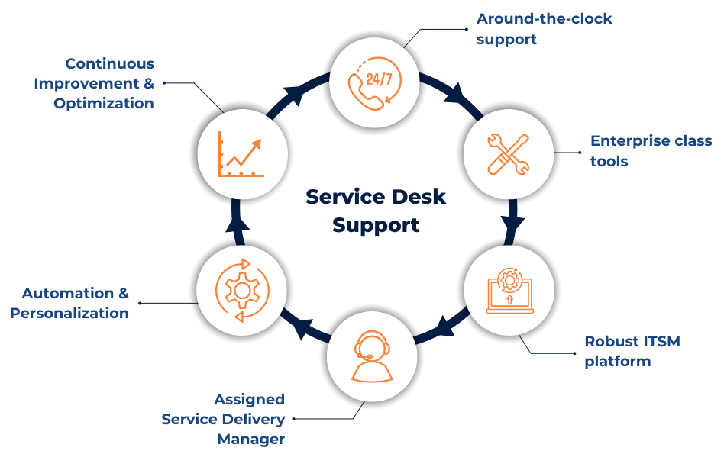
Our Features:
- 24/7/365 remediation remote support for requests, incidents, and problems, backed by our SLA guarantee
- Enterprise-class tools to troubleshoot and remediate end-user requests
- Robust Service Desk platform, customized to meet your needs
- Dedicated support email and phone number
- Knowledge base and self-service portal
- Contextual reporting, which highlights current trends and recommendations
- Training sessions on M365 or other business-critical applications to help users optimize productivity
- Assigned Service Delivery Manager
In-Scope Activities:
- Password resets, access requests, & group changes across workstations, servers, and M365 environments, including email system management
- Workstation & peripherals break / fix, support & provisioning/deprovisioning including escalation to OEM support
- Multi-Factor Authentication (MFA) troubleshooting support (Arraya is assuming that TKC has M365 licensing levels that support MS Defender)
- Printer and scanner services and management
- Alert and monitor all in-scope workstations and work with end-users to remediate alerts on a proactive basis
- Mobile Device Management (MDM) and support (Arraya is assuming that TKC has M365 licensing levels that support Intune)
- Escalation to third-party vendors; vendor management
- OS Image deployment and configuration
- Application of OS/driver/software updates
- User Profile registration and system preparation
- Workstation shipping to designated users
- Equipment receipt and damage assessment
- Break/fix coordination under manufacturer warranty
- Asset management and inventory reporting
- Decommission planning (out of warranty, non-functional equipment)
- Nationwide Smart Hands Support: our team will oversee the coordination efforts so you can take advantage of quality, in-demand skills, without the overhead

Security Operations Center (SOC) Support
Recent years have shown that the stakes surrounding cyber security are only increasing. As organizations rely on technology in new ways, hackers are escalating their attacks in complexity, frequency, and severity. Today, securing your business’s network, applications, infrastructure, and data is vital to its success. As threats evolve every day, cyber security is a continuous journey, not a finite solution.
This is where our Managed Security Operations Center (SOC) comes in. Acting as the front line of defense, our SOC team provides proactive threat monitoring, rapid incident response, and strategic guidance to help safeguard your organization. By leveraging cutting-edge tools and industry best practices, we ensure your business remains resilient against evolving cyber threats.
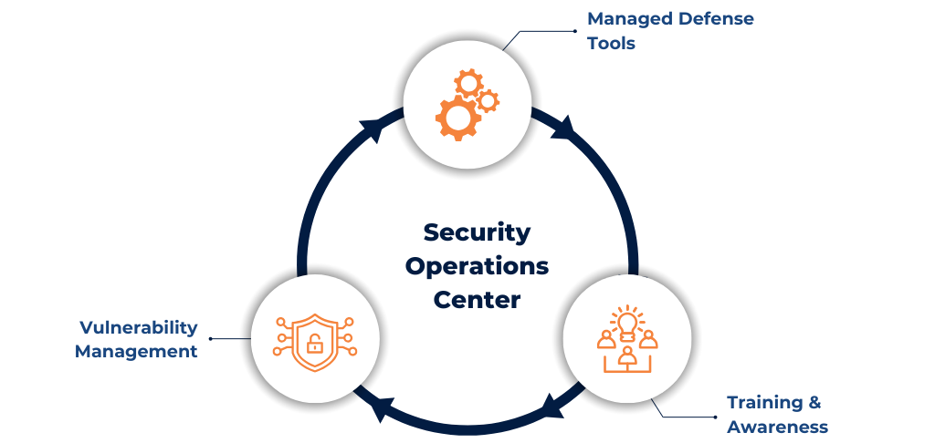
Our Features:
- Around-the-clock support with recommended solutions to ensure a healthy and secure infrastructure
- Enterprise-class tools to safeguard your environment and end-users

In-Scope Activities:
Security Training and Awareness Support
- Security awareness training for end users
- Simulated phishing campaigns
- Remedial training to impacted end-users
- Training completion statistics and campaign click-through reviews
Endpoint Detection & Response (EDR) Support
- Process execution monitoring for threat detection on eligible workstations
- Incident reporting for verified threats or action(s) needed
- Remediation assistance including quarantining affected workstations
- Dashboard configuration changes to support activity monitoring
- Service dashboard and report reviews
Vulnerability Management
- Monthly System Vulnerability Lifecycle Compliance / Management to ensure compliance with baselines
- Monthly vulnerability reporting (internal and external)

Alert & Monitoring as a Service (AMaaS)
Arraya’s enterprise monitoring and support service is all about responsiveness. It monitors the availability, health, and performance of your infrastructure– 24/7, 365 days a year. The true value is linking your IT team with ours. Our experts get to know your environment, giving them the knowledge to stay one step ahead of genuine issues.
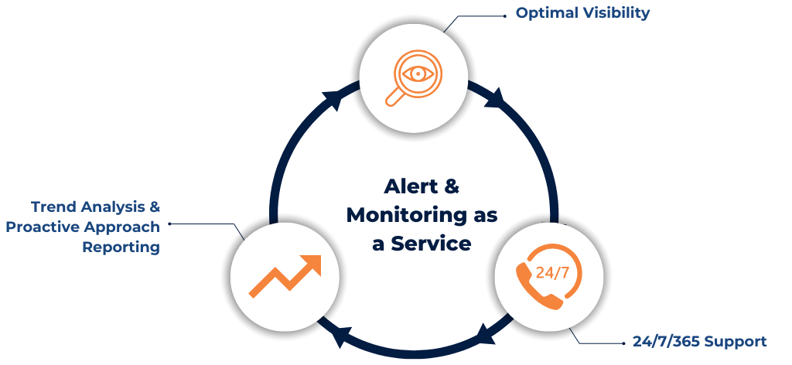
Our Features:
- Real-time monitoring
- Automated alerts are integrated with our ITSM for seamless support
- Enterprise-class monitoring tools with customized dashboards
In-Scope Activities:
- 24/7/365 alert and monitoring of cloud and on-prem devices to ensure service availability
- Acknowledge, prioritize, manage, and respond to alerts using Arraya’s monitoring platform
- Monthly reporting including alert details, trends and recommendations
AMaaS provides a base foundation from which IT assets and equipment can be managed. This is a key component of IT lifecycle management and a prerequisite service.

Lifecycle Management as a Service (LMaaS)
With years of experience and a Professional Services and Managed Team to back you up, Arraya Solutions excels in LMaaS, offering tailored, industry-specific solutions with a focus on operational efficiency, security, and strategic alignment. Our award-winning services combine a friendly approach with advanced technologies, enhancing your business's growth through cost-effective, productive, and scalable IT asset management. We ensure your IT infrastructure meets current demands and adapts seamlessly to future technological advancements, aligning IT resources with your business goals for comprehensive expansion support.
Arraya employs a pragmatic approach to Lifecycle Management that aligns with the latest ITIL standards. The goal is to keep focus on IT service delivery and acknowledge all the systems and equipment that host, integrate, interact, and/or impact key business applications.

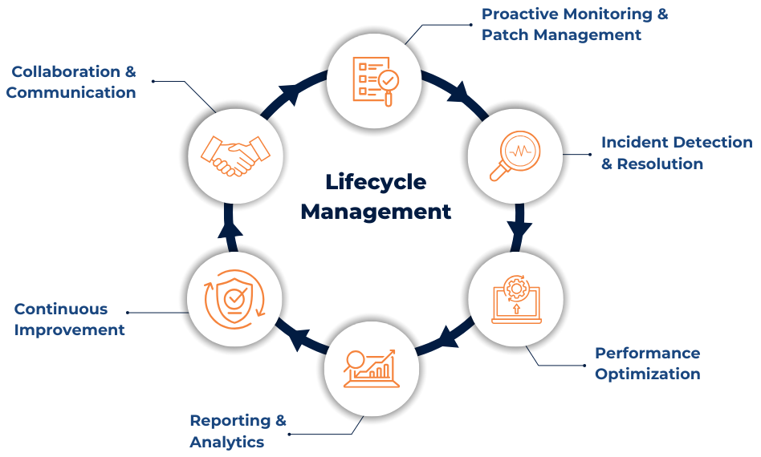
Our Features:
- Alert & Monitoring as a Service (AMaaS) & remediation support
- Patch Management as a Service (PMaaS) & preventative maintenance
- Around-the-clock support with recommended solutions to ensure a healthy and modernized infrastructure
- Review of upcoming end-of-life devices and technology roadmap planning
In-Scope Activities:
Monitoring, Management & Support
- Perform continuous monitoring for system availability and performance, including issue diagnosis and troubleshooting
- Manage configuration changes remotely in coordination with your subject matter experts
- Provide IT Asset Management (ITAM) for all hardware and software warranties and renewal dates
- Provide 24x7 operational support adhering to Service Level Requirements
- Business Continuity and Disaster Recovery (BCDR) planning and support
Patch Management & Preventative Maintenance
- Install the latest patches and updates for each in-scope device
- Identify and schedule major code/firmware upgrades
- Identify equipment that is end-of-life or end-of-support and work with Customer on recommendations
Escalation & Problem Resolution
- Develop escalation workflows for issues and requests beyond the initial scope
- Work with third-party vendors for additional support when required
- Proactively monitor vendor-related upgrades and plan initiation with customer
- Provide escalation support for unresolved issues
Reporting & Continuous Improvement
- Review service dashboards and reporting capabilities with your organization
- Prepare reports on ticket activity, ITAM, and service level compliance
- Store and maintain information on your organization’s environment for effective troubleshooting and recommendations
- Assist with procuring equipment to abide by provided recommendations
- Assist with recommendations, planning, and implementing hosting initiatives with collocation and cloud partners, depending on requirements
Process Integration & Compliance
- Review and incorporate your change controls into Arraya’s processes
- Manage services onboarding, steward incoming service requests, and maintain contract scope
Asset Management & Knowledge Base Support
- Track inventory within Arraya’s IT Asset Management (ITAM) platform. This platform shows details about asset health and warranty details
- Track active certifications and software renewals
- Store and maintain Standard Operating Procedures (SOPs) around your environment
- Provide support resources context to troubleshoot issues effectively
- Recommend changes to improve IT service availability, operations, or performance
Deliverables:
- A dedicated Service Delivery Manager ensures your IT services are finely tuned to your business requirements
- Our state-of-the-art tools safeguard your operations, providing peace of mind and operational stability
- We document your systems for transparency and understanding
- Proactive management of upgrades and EOL equipment keeps you ahead of the technology curve
- We deliver concise, meaningful reports for strategic decision-making, helping you grow and succeed
- Our 24/7 operational support stands ready to tackle issues, minimize downtime, and maximize productivity
- We align closely with your business's rhythm by customizing our services to mesh with your existing processes

Implementation Plan
Arraya understands that onboarding a managed services customer requires a structured process to ensure continuous alignment, deployment, security, and compliance. During the onboarding phase, our teams will collaborate to ensure successful engagement and reliable, top-tier support. We pride ourselves on measuring our success during this phase while keeping TKG’s business objectives and end-users top of mind.
Please see our Implementation Plan below, which displays key requirements and an estimated timeline. This timeline displays implementation per each location. Arraya will communicate with TKG stakeholders throughout the entire process. The plan will be stored centrally and available to all stakeholders. Arraya will also identify any risks or gaps during the implementation phase and communicate with TKG. Risk mitigation efforts will be established to ensure we are adhering to timeline efforts.
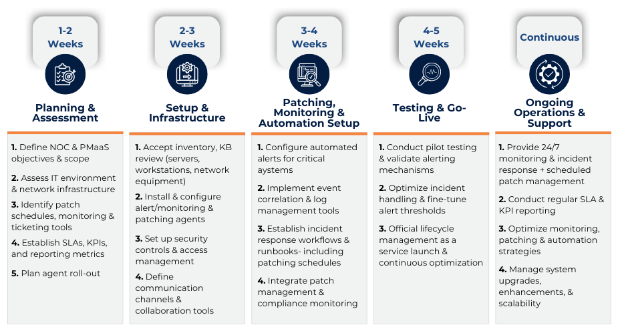

Consulting Services

IT Management Policy & Procedure Support
An added benefit to Managed Services is the opportunity it offers service providers to evaluate and improve on a customer’s existing IT policies and procedures. IT policies reflect a statement of principles and strategy while procedures represent the steps necessary to turn these ideas into action. Taken together, they form the framework that supports IT Operations and delivery of service.

Arraya adheres to best practices and promotes the following keys to developing effective IT policies and procedures:
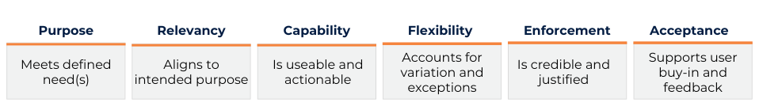
Throughout the customer journey, Arraya’s Service Delivery Manager will lead efforts to evaluate procedures and benchmark supporting policies using these criteria. The SDM will produce and promote a roadmap for exploring efficiencies. The goal, beginning with onboarding, is to learn, understand, and improve IT policies and procedures in the following areas:
- Acceptable Use
- Security & Data Privacy
- Technology Standards
- Service Delivery
- Organization
- IT Operations
Team members are encouraged to share their thoughts and ideas for promotion during monthly and quarterly meetings. This information is stored centrally and available to all parties.

Evaluating Performance
Managed Services are based on trust and reflect prevailing sentiment around resource capacity, capability, and engagement. How a customer feels about the people that support them is often more important than the number of tickets closed, or service requests processed. Arraya believes introducing the right people to an account, individuals that align both technically and culturally, is the best way to build long-standing customer relationships.
That said, monitoring and benchmarking performance using objective measurement is a primary service provider responsibility that Arraya takes seriously. Arraya’s Service Delivery Managers use the onboarding period to map in-scope activity to expected and acceptable processing times. These service levels form the basis for service-level objectives, which define performance and provide clear targets for team members. Regular monitoring and reporting ensure Arraya resources are closing tickets and managing requests productively.

IT Strategy & Advisory
Defining and refining process standards, establishing IT budgets that reflect current/future technology needs, evaluating operational performance for efficiencies, and supporting due diligence/compliance, are all responsibilities for which IT leadership is accountable. In scenarios where a customer does not have executive representation in one or more areas, Arraya provides advisory services on a supplemental basis, as needed, to monitor and govern these activities.
Arraya has senior leaders with industry experience available to consult that take the form of virtual, or vCxO, level services. Customers can consume vCxO services on a fixed basis (subscribing to a set number of hours per period – typically monthly) or variable basis (time and materials for hours worked – typically tied to specific initiatives).

Account Management
When partnering with Arraya, we ensure that our customers feel supported. During on-boarding, a Service Delivery Manager (SDM) will be assigned to your account. Arraya’s SDM acts as the single point of contact for Customer across all of Arraya’s departments and resources. This resource takes ownership of escalations to establish effective communication between stakeholders. They are accountable for service delivery performance, satisfying customer expectations, and pushing on-demand requests. The SDM collaborates with you on a recurring cadence, tracks, and reports on KPI metrics.
In addition to your SDM, Arraya’s Operations Director, Account Executive, and Executive Sponsor will also be additional escalation contacts.

Service Level Management
Arraya acknowledges that the value of an MSP is its ability to deliver in-scope services with consistency. This means that incidents, problems, and service requests are documented, categorized, processed, and resolved in an efficient and timely manner. These activities can be measured objectively and reflect desired service levels communicated by the customer (Globus Medical) and assumed by the service provider (Arraya).
Arraya provides the following definitions of severity and service level objectives for reference based on initial discovery. Further items, including the Service Level Agreement itself, will be defined in the Service Desk support agreement.

Service Definitions
Submission Time – Time when Customer raises an issue through one of the supported methods.
Assignment Time – Time when Arraya support team member assumes ownership of the issue and responds to the Customer to begin initial triage.
Response Time – Time difference between Submission Time and Assignment Time.
Response Escalation – Time interval following Submission Time when an issue has not been assigned to an Arraya support team member and/or the Customer has not received a response to begin initial triage.
Priority – Classification of issue severity, reflected as a combination of urgency and impact, to be applied by Arraya support team members following Submission Time and adjusted as necessary according to the following descriptions:

Priority | Description
1 (Critical) | A site, production server, workstation, or service is down, resulting in critical impact to business operations.
2 (High) | A site, production server, workstation, or service is degraded, negatively impacting business operations.
3 (Medium) | A site, server, workstation, or service exhibits abnormal behavior negatively impacting business operations, but in-place workaround or redundancy exists.
4 (Low) | A site, server, workstation, or service exhibits abnormal behavior that does not impact business operations.

Service Level Objectives
Arraya commits to the following response time, response window and response escalation thresholds to ensure consistent, efficient incident and problem resolution.
Priority | Response Time | Response Window | Response Escalation
1 (Critical) | 30 minutes | 24x7 | +0:30
2 (High) | 1 hour | 24x7 | +2:00
3 (Medium) | 8 hours | 24x7 | +4:00
4 (Low) | 24 hours | 24x7 | +12:00

Our Approach
Our approach to providing managed IT services to TKC is based on the following principles:
- We will collaborate with your current provider and staff members to understand your IT environment, challenges, and goals.
- We will leverage our expertise, tools, and best practices to deliver reliable, secure, and efficient IT services across your network, infrastructure, applications, and data.
- We will provide proactive monitoring, maintenance, and support for your IT systems, as well as strategic guidance and consulting for your IT projects and initiatives.
- We will measure and report on our service performance and customer satisfaction and continuously seek to improve our service delivery and outcomes.

Our Pricing
Arraya Solutions is pleased to offer TKC a comprehensive and cost-effective managed IT services package that will meet your current and future needs. Our proposal is based on a thorough review of the information outlined in the RFP. We aim to partner with you to deliver high-quality IT support, optimize your IT operations, and reduce your IT expenses.
The tables below summarize monthly recurring pricing for the proposed solution for ALL eligible site locations. Unit pricing includes all resource, software and tools costs necessary to deliver the services in scope.

Managed Services Pricing (by Unit)
Service Tower | Pricing Unit | Frequency | Unit Price Per Month
Service Desk Support | User | Monthly | $22.00
Managed Security Operations (SOC) | User | Monthly | $15.00
Alert & Monitoring as a Service (AMaaS) | Device | Monthly | $10.00
Lifecycle Management as a Service (LMaaS) | Device | Monthly | -
Firewall/Edge Appliance | Device | Monthly | $200.00
Router/ISR/Gateway | Device | Monthly | $500.00
Switch | Device | Monthly | $15.00
Wireless  (Cloud-Managed AP) | Device | Monthly | $3.50
Server (Host/Virtual) | Device | Monthly | $200.00
DAS/SAN | Device | Monthly | $250.00

Kendal Site Breakdown (by Unit)
Site Locations | Eligible Users | Endpoints | Firewall | Router/  ISR | Switch | WIFI | Server | SAN | Device Total
Kendal at Home | 24 | 21 | 1 | 5 | 1 | 2 | 2 | 1 | 12
Collington | 116 | 79 | 2 | 1 | 79 | 356 | 5 | 1 | 444
Kendal at Ithaca | 165 | 107 | 2 | 1 | 20 | 148 | 8 | 1 | 180
The Lathrop Community | 43 | 43 | 3 | 0 | 8 | 15 | 5 | 1 | 32
Kendal at Oberlin | 168 | 165 | 2 | 1 | 33 | 301 | 12 | 1 | 350
Kendal at Lexington | 122 | 72 | 0 | 1 | 87 | 251 | 5 | 1 | 345
Kendal at Sonoma | 62 | 51 | 2 | 1 | 35 | 163 | 4 | 1 | 206
Kendal on Hudson | 102 | 162 | 2 | 1 | 22 | 225 | 6 | 1 | 257
Kendal at Hanover | 156 | 120 | 2 | 2 | 24 | 237 | 17 | 1 | 283
Barclay Friends | 96 | 135 | 2 | 1 | 9 | 55 | 9 | 1 | 77
T K C | 89 | 30 | 2 | 1 | 2 | 2 | 6 | 2 | 15
Subtotal | 1,143 | 985 | 20 | 15 | 320 | 1,755 | 79 | 12 | 2,201

Kendal Solution Pricing (by Service Tower & Location)
Site Locations | Service Desk¹ | SOC | AMaaS² | ITLM | MRR (Site)
Kendal at Home | $528.00 | $360.00 | $100.00 | $3,372.00 | $4,360.00
Collington | $2,552.00 | $1,740.00 | $880.00 | $4,581.00 | $9,753.00
Kendal at Ithaca | $3,630.00 | $2,475.00 | $320.00 | $3,568.00 | $9,993.00
The Lathrop Community | $946.00 | $645.00 | $170.00 | $2,022.50 | $3,783.50
Kendal at Oberlin | $3,696.00 | $2,520.00 | $490.00 | $5,098.50 | $11,804.50
Kendal at Lexington | $2,684.00 | $1,830.00 | $940.00 | $3,933.50 | $9,387.50
Kendal at Sonoma | $1,364.00 | $930.00 | $430.00 | $3,045.50 | $5,769.50
Kendal on Hudson | $2,244.00 | $1,530.00 | $320.00 | $3,467.50 | $7,561.50
Kendal at Hanover | $3,432.00 | $2,340.00 | $460.00 | $6,239.50 | $12,471.50
Barclay Friends | $2,112.00 | $1,440.00 | $220.00 | $3,527.50 | $7,299.50
T K C | $1,958.00 | $1,335.00 | $130.00 | $5,137.00 | $8,560.00
MRR | $25,146.00 | $17,145.00 | $4,460.00 | $43,992.50 | $90,743.50
(¹ Used M365 license count to estimate eligible user count by site location (E1/E3/E5/F3/EOP P1)
(²Cloud-Managed Access Points not included in AMaaS)

Onboarding Fees
Initial onboarding fees will be billed upfront equal to the first monthly fee.
Fee Consistency
Arraya acknowledges that efficiencies in delivery over the length of term are sometimes offset by increasing labor and software costs. Arraya aims to keep unit rates consistent, with any price increases transparent flexibility to keep unit rates consistent and provide the opportunity to lock in pricing with extended terms.

Additional Support
Additional support may be requested by the Customer. Please refer to the table below for hourly rates. Additional support will only be billed if the Customer approves in writing.
Service | Hourly Rate
Smarthands (Onsite planned support; NBH) | $175.00 / hour
Project Implementation Support
Project Management Support | $200.00 / hour
Project Engineering Support | $250.00 / hour
Advisory (vCxO) Services | $300.00 / hour

Firm Qualifications
Company Profile
Arraya Solutions was founded in 1999 by Dan Lifshutz and David Bakker with a mission to combine technological expertise and personal service to educate and empower customers to solve their individual IT challenges. Today, Arraya Solutions is a global IT consulting and managed services provider (MSP) that offers a wide range of services to streamline IT operations, enhance security, and drive business efficiency. The company's core offerings include Network, Hybrid Infrastructure, Cybersecurity, and Modern Workplace. Arraya Solutions partners with multiple leading providers in the industry to ensure they provide white glove service for all IT needs. Arraya is headquartered in Blue Bell, PA and operates solution centers in the US, Colombia and Philippines with a total of 125 employees.

MSP Experience Including Nonprofit
Arraya's extensive range of services across the IT ecosystem enables us to be trusted consultants, guiding you through any business challenge that IT supports. Arraya has assisted several nonprofit organizations over the years in several ways. With our focus on offering tailored IT services and solutions that help organizations operate more efficiently, securely, and cost-effectively. We understand that nonprofits typically rely on donations or grants and must work within a fixed budget year or year. We support organizations that have fewer than 10 employees to over 5000 globally. Here are some key highlights on how we support nonprofits:
Industry Recognized: Arraya Solutions has been recognized on CRN's MSP 500 list in the Elite 150 category for nine consecutive years as of 2024, showing their long-standing presence and expertise in the MSP space
Remotely Available: Arraya has experience in establishing secure remote access to the organization’s systems, enabling staff and volunteers to work from anywhere, which is especially important in today's remote and hybrid work environments.
Best in Class Tools: Arraya has experience in implementing and supporting collaboration tools like Slack, Teams, or Zoom, helping nonprofits coordinate efforts among staff, volunteers, and stakeholders.
IT Roadmap Support: Arraya has assisted many organizations in creating an IT roadmap that aligns with their mission, budget, and long-term goals. This can include strategies for scaling IT infrastructure.
Technology Advice: Arraya can provide advice on technology solutions for specific nonprofit needs, such as data analytics tools.
Cloud Solution Provider (CSP): Arraya is a certified CSP and can help consult and acquire the appropriate cloud licenses based on functionality and budget considerations based on experiences across Arraya’s user base.

Transfer of Services
Arraya’s Managed Services has vast experience in transitioning services to our customers. We have a detailed on-boarding plan and well-trained staff to support all the transition tasks. Below we highlight criteria to ensure success during this important transition:
Availability
  - Ensuring your current provider or staff is available to discuss tasks and associated timelines.
  - Ensuring your key personnel are available for all training items.
Access
  - Ensuring your current provider and/or internal IT gives us access to all in-scope systems, applications, etc.
  - Ensuring we have proper channels of access for your end-users so we can provide adequate training materials and support.
Knowledge Base & Compliance
  - Ensuring we obtain all relevant and active knowledge base articles specific to SOPs, compliance regulations, and ongoing support needs.
  - Ensuring active collaboration between Arraya and internal IT to define, enhance, and document change control procedures.

Communication
  - Keeping all lines of communication active and open between Arraya, current support channels, and key personnel. Your assigned SDM will be top of the line and will highlight phases throughout the transition period.

Key Personnel & Staff Continuity
Arraya Solutions Managed Services has a top-tier technical team, which is consistently recognized in MSP Elite 150. The Arraya team is nimble and flexible, allowing us to scale with our customers' growth while ensuring customer needs are met through clear and transparent contracts and excellent CSAT ratings. Additionally, Arraya Solutions has been recognized as a top workplace by multiple organizations, including Philadelphia Inquirer and Great Place to Work. We pride ourselves on our current employee retention and follow a comprehensive training and employee-growth plan. Please see details around some of our resources that will be a part of this project.
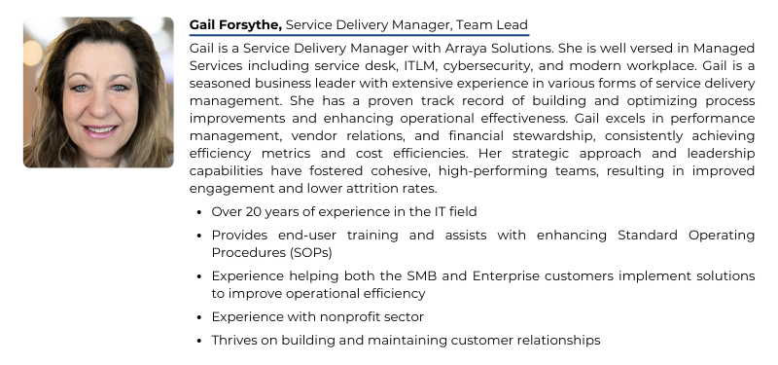
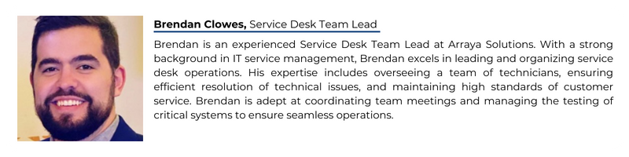
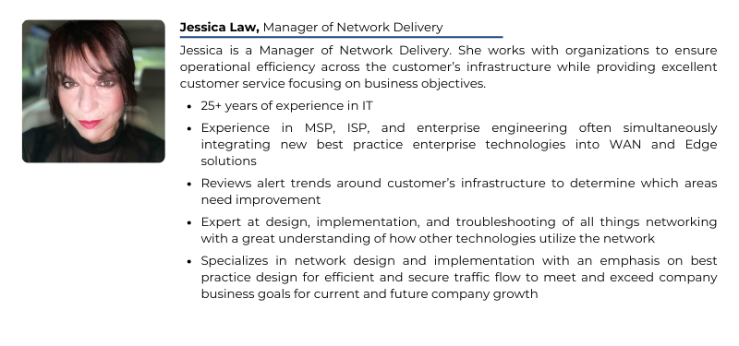
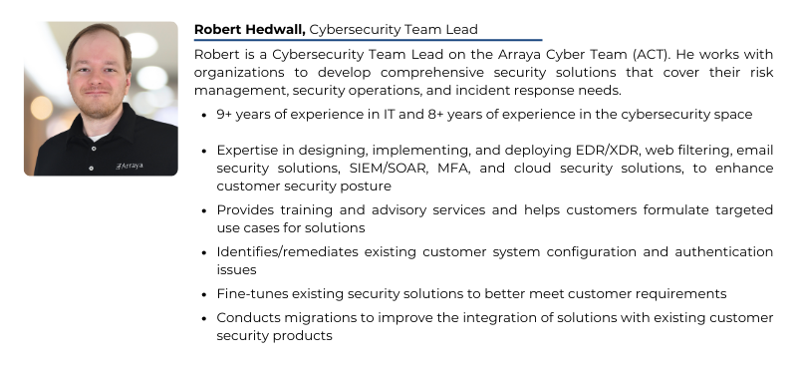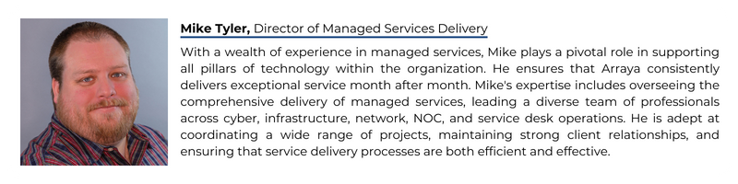

References
We are pleased to share that Arraya has been a steadfast presence in the business community for over 25 years, with our roots deeply embedded in Pennsylvania, New Jersey, and Delaware. Our longstanding commitment to these states has resulted in many references from satisfied customers within the region. Our dedication to providing exceptional service remains unwavering, and we are excited for the opportunity to bring our wealth of experience and expertise to you.
All the customers included as references have agreed to speak to TKC. To respect our customers’ privacy and time, they have asked to have reference meetings/phone calls coordinated through Arraya. When TKC is ready to engage with these companies, please contact your Arraya Account Manager, Shawn Reber, and he will coordinate the meeting times.
