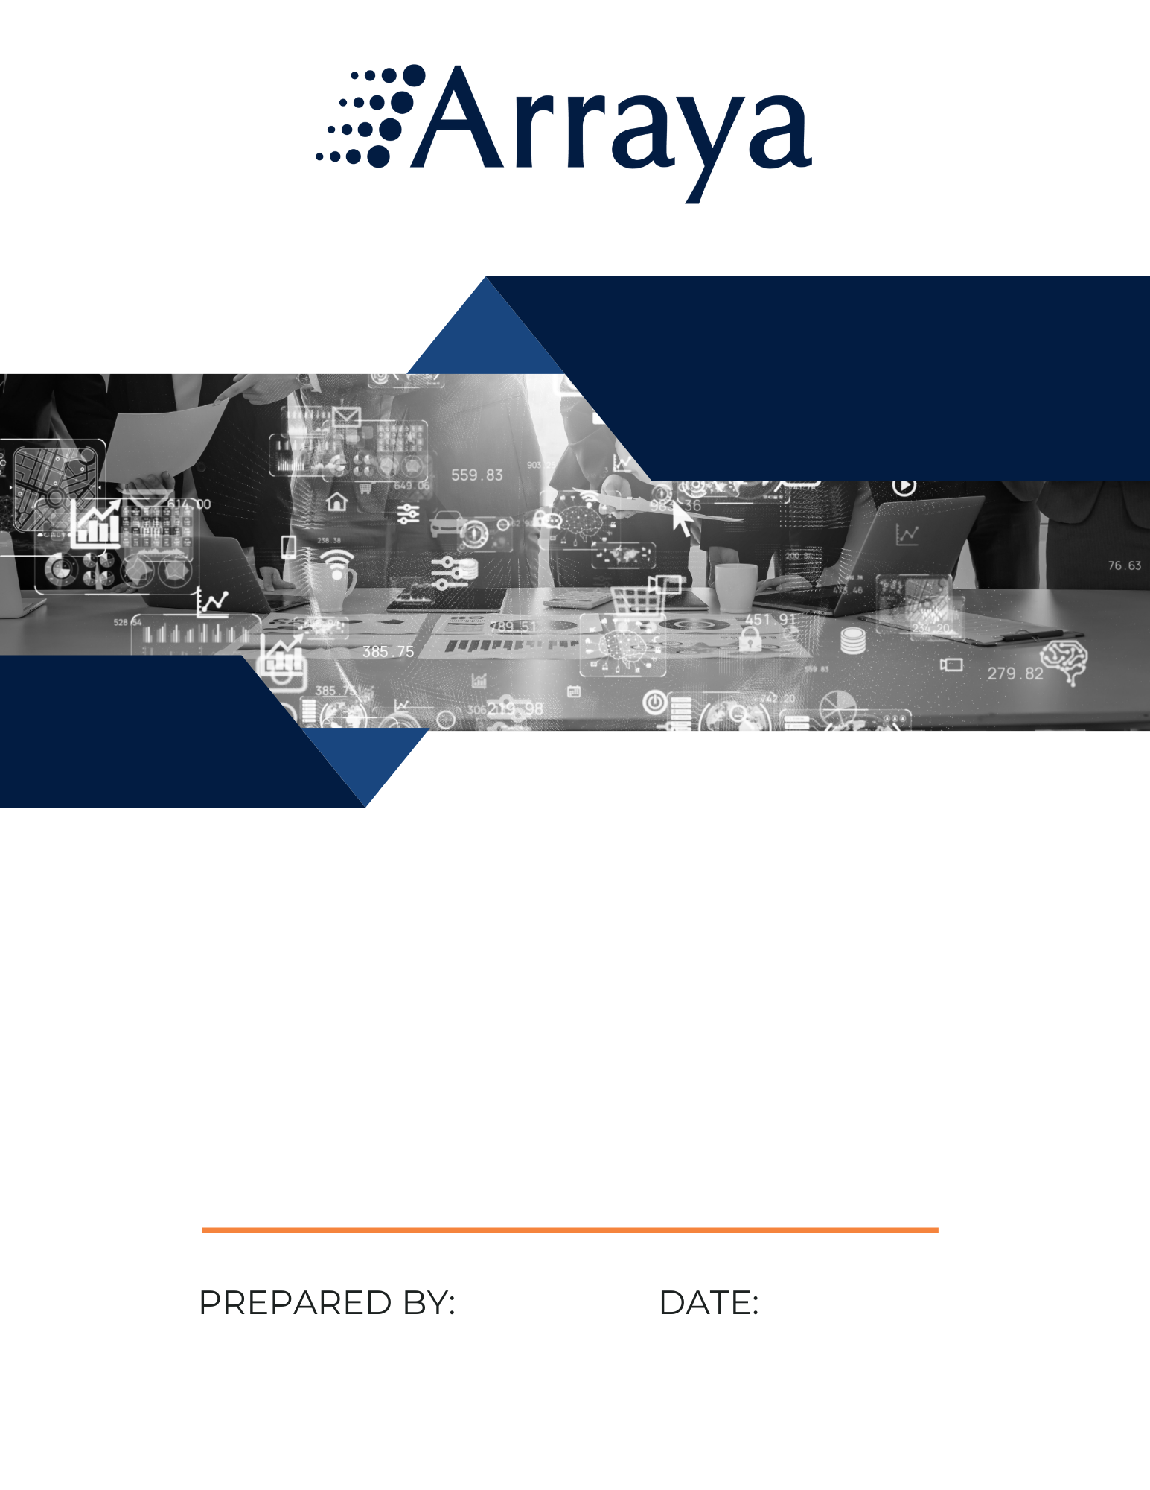
RFI Solution Summary
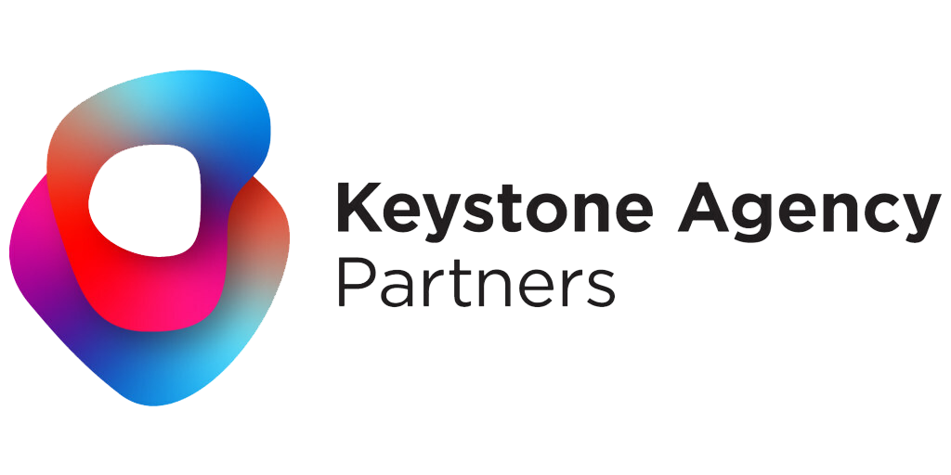
June 3, 2025
Teddy Jennings
June 3, 2025
Dear Keystone Agency Partners,
As a leader in IT management, Arraya is committed to delivering seamless and efficient IT support that aligns with the business goals of Keystone Agency Partners (KAP).
Operational Capabilities: Arraya Solutions has 26 years of experience in streamlining processes and implementing cutting-edge technologies. Arraya Solutions proposes a holistic approach to managing KAP’s needs. Our services will encompass hardware support for servers, laptops, peripherals, and network devices, as well as network and software monitoring. We will provide a robust service desk, ensure reliable back-ups, maintain remote access and on-site support, manage email systems, and oversee inventory control for both hardware and software. Our security measures and disaster recovery plans will be designed to protect and sustain KAP’s IT infrastructure.
Cost Efficiency: Our partnership is structured to ensure that cost savings are realized by both KAP and Arraya Solutions. This shared investment model incentivizes both parties to find innovative ways to reduce expenses without compromising quality.
Strong Partnership: Together, we will set measurable goals and track progress towards achieving them. Our partnership will focus on the outcomes that matter most to KAP, such as consolidating and centralizing IT and entrusting one partner to manage and support the environment. With Arraya Solutions by your side, we are confident in our ability to deliver tangible results that benefit your organization.
A partnership with Arraya Solutions represents a strategic alliance that drives innovation, efficiency, and cost savings. We are eager to embark on this journey together, and we look forward to the positive impact it will have on your business operations. Thank you for the opportunity.

Warm Regards,
Teddy Jennings
Teddy Jennings
Account Executive

Table of Contents
Company History 4
Customer References 5
Arraya’s Solution 5
Migration Project Support 6
Key Features 6
Managed Services Engagement Model 7
Service Desk Support 7
Key Features 8
Lifecycle Management as a Service (LMaaS) 8
Key Features 9
Security Operations Center 9
MSP Questionnaire 11
Company Information 11
General Questions 12
Security, Compliance, Technology 15
Process, Service, Support 19
Contracts & Commercials 23
Arraya Pricing Model 24
Arraya Internal Cybersecurity Controls 24

Company History
Arraya Solutions is a full-service IT solutions provider with a proven track record of helping organizations modernize, secure, and scale their IT environments. We have deep experience supporting private equity-backed companies, including Bane Capital portfolio companies, by delivering agile and scalable IT solutions aligned with growth targets and acquisition timelines.
Our engineering and architecture teams bring cross-functional expertise across a wide range of OEMs and ISVs, enabling us to design and implement tailored solutions that span the entire Microsoft stack, data center, cloud, cybersecurity, networking, collaboration, and application dev subject areas. We also help organizations explore and adopt Generative AI solutions to unlock new efficiencies, automate workflows, and enhance decision-making across the business.
We support our clients through the initial strategy development through full-scale implementation. Arraya offers flexible delivery methods to meet a wide range of business needs, including:
- Simple transactional sales for hardware and software procurement
- Professional services for project-based engagements such as network hardware refreshes, cloud migrations, and security upgrades
- Advisory services for both short-term and long-term strategic IT planning
- Fully managed services for ongoing operational support
- Contract-to-hire services that provide skilled IT professionals on a short-term or long-term basis as needed
With 26 years of industry experience, Arraya provides a scalable Managed Services engagement model with predictable pricing to ensure cost transparency and operational flexibility. Our approach is backed by strong documentation practices, compliance support, and a customer-first mindset, positioning Arraya as a strategic partner committed to your long-term success.

Customer References
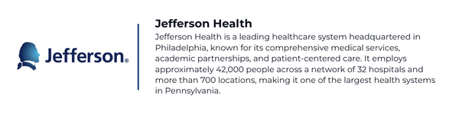
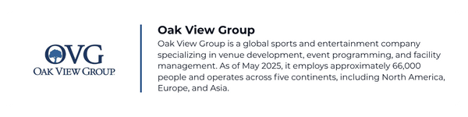

* Customer reference calls can be scheduled upon request.

Arraya’s Solution
Arraya is proposing the following operational support services from our Service Catalog. These services were selected because they align with KAP’s requirements and build on one another in a cost-effective manner. Arraya can provide any/all of these services today, and service consumption is flexible to allow for scalability in the future.
- Migration Project Support
- Managed Services Engagement Model
- Service Desk Support
- Lifecycle Management as a Service
- Security Operations Center (SOC) Support

Migration Project Support
At Arraya, we take pride in packaging solutions that provide our customers with support and reliability from project initiation to closure and into ongoing operations support. We have extensive experience in IT support for mergers and acquisitions (M&A). Our support models ensure seamless integration, data security, and business continuity throughout the project lifecycle.
We have developed a comprehensive approach based on our experience supporting mergers, acquisitions, and divestitures-modeled companies. Our approach emphasizes the importance of careful planning and integration. We focus our efforts on consolidating and simplifying where applicable. Our integration strategy is designed to avoid data loss, ensure secure access, conduct thorough management assessments, align security policies, apply effective project management, and unify systems to reduce costs and improve efficiency.

Key Features
- Messaging Platform Consolidation: Unifying messaging and collaboration platforms is crucial. Temporary integrations can bridge gaps during the migration process.
- Identity & Access Management: Ensuring seamless and secure access for all employees in the newly combined organization.
- Document Management Services: Thorough assessment of document management services, with temporary external sharing settings to facilitate collaboration.
- Security Optimization & Integration: Aligning security policies to protect against threats during the transition.
- Project Delivery & Management: Leveraging prior experience to identify and address bottlenecks that may slow the migration process.
- Integrate Windows Servers: Uniting network and server assets under one integrated system to lower costs and reduce identity management issues.

Managed Services Engagement Model
Arraya has built a nationally recognized Managed Services practice, named to CRN’s MSP 500 list as one of the MSP Elite 150 for multiple consecutive years. Our Ascend Managed Services model is designed to meet customers where they are and scale as their business grows, whether supporting fast-moving startups or large enterprise environments. Each customer is paired with a dedicated Service Delivery Manager (SDM) who provides a single point of contact, leads regular service reviews, and ensures seamless coordination between your team and ours. These reviews offer insights into ticket trends, SLA performance, and proactive recommendations to continuously improve your IT environment.
Powered by the Ascend model, Arraya delivers 24x7x365 support through a flexible, transparent engagement model that prioritizes uptime, security, and operational efficiency. Customers can engage us via phone, email, or integrated Microsoft Teams chat, ensuring fast, convenient support whenever it's needed. To maintain the highest standards, our team holds certifications from top governing bodies and OEMs, including but not limited to (ISC)², CompTIA, Microsoft, Cisco, and Dell. With deep technical expertise, a customer-first mindset, and a commitment to continuous improvement, Arraya serves as a strategic partner invested in your long-term success.

Service Desk Support
As companies grow and merge, it is important that support grows as well. Arraya acknowledges the value of being scalable, and we have developed the service with this approach in mind.
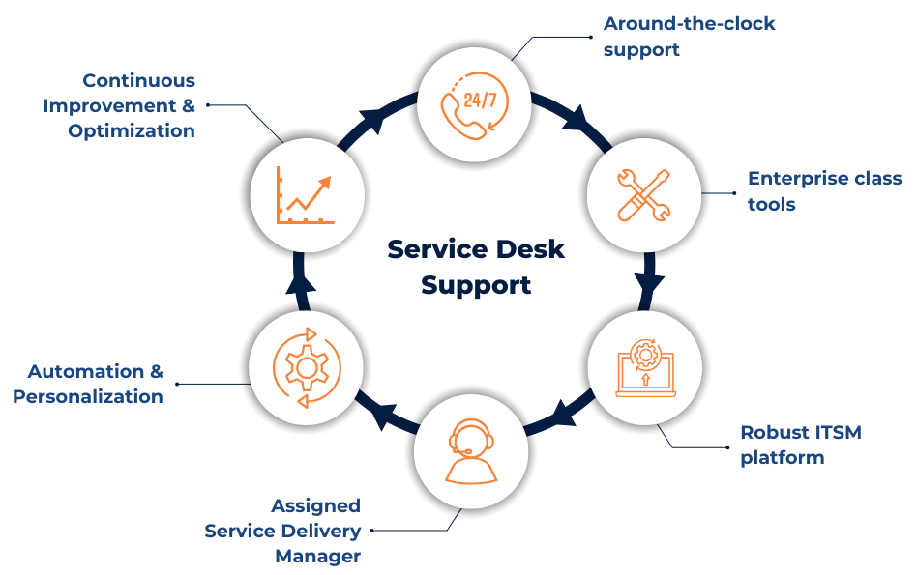

Key Features
- Around-the-clock remediation and remote support for requests, incidents, and changes, backed by our SLA guarantee
- M365 support and backup
- End-user onboarding/offboarding, device procurement and management (ITAM), including Patch Management
- Enterprise-class tools to monitor, troubleshoot, and remediate end-user requests
- Robust ITSM platform, customized to meet your needs
- Support email, phone number, and integrated chat
- Knowledge base and self-service portal
- Contextual reporting, which highlights current trends and recommendations
- Training sessions to help users optimize productivity
- Dedicated Service Delivery Manager

Lifecycle Management as a Service (LMaaS)
Our infrastructure solutions team specializes in delivering solutions across both cloud and on-prem environments. The team's capabilities are adaptive, with skillsets and experience across multiple OEM vendors such as Azure, AWS, Dell, Cisco, Fortinet, Palo Alto, Ubiquiti, and more. For Azure, we help design and support secure virtual architectures, hybrid connectivity (VPN/ExpressRoute), and enforce policies around access control, routing, and segmentation. We also provide hands-on administration and troubleshooting to ensure your Azure environment performs the way it should. Whether you’re expanding your cloud presence or building out hybrid environments, we align our services to your technical and business goals.
On the physical side, we handle full lifecycle support for standardized infrastructure devices, from staging and pre-configuration to on-site installation and validation. Devices arrive ready to deploy, with golden templates, asset tracking, and tested configs. Our field engineers take care of cabling, mounting, turn-up, and ongoing maintenance. The result is a smoother deployment process, less time on site, and a network that’s up and running exactly how you need it.
In addition to professional services, Arraya will support KAP’s network environment around the clock. Our team consists of Level One to Level Three engineers who work across three shifts. We will also manage and support unified communications (UC) systems. These systems include voice, video, messaging, conferencing, presence, and collaboration tools.
Arraya employs a pragmatic approach to Lifecycle Management that aligns with the latest ITIL standards. The goal is to keep focus on IT service delivery and acknowledge all the systems and equipment that host, integrate, interact, and/or impact key business applications.

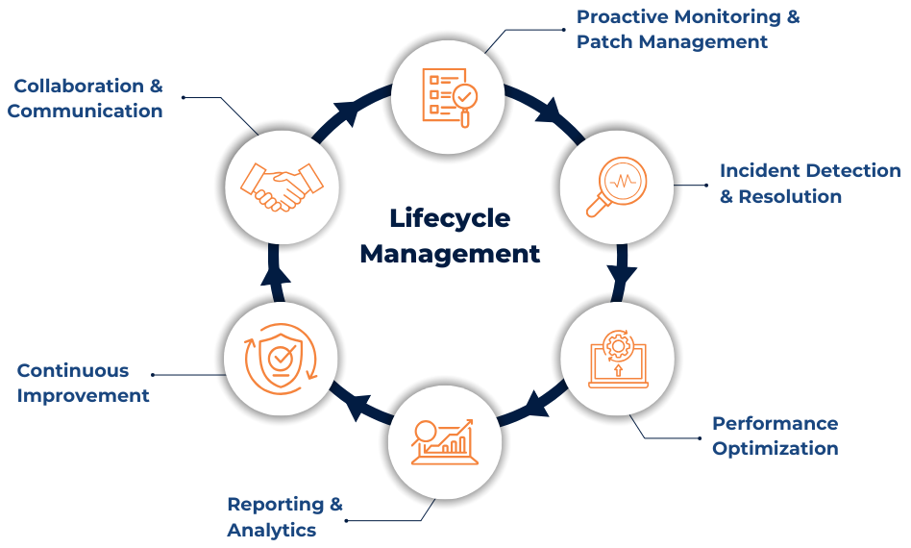

Key Features
- Around-the-clock support with recommended solutions to ensure a healthy and modernized infrastructure
- 24/7/365 availability and performance monitoring of network, cloud, and UC devices
- Level 1 & 2 remote remediation services for incidents and requests
- Moves, adds, changes, and deletions (MACDs) to the existing configuration of infrastructure, including firmware updates and patching
- Review of upcoming end-of-life devices and technology roadmap planning
- Regular reporting on trends, service level measures, and recommendations
- Document and maintain a ‘living’ knowledge base

Security Operations Center
The Arraya Cybersecurity Team has overseen the implementation and administration of multiple industry-leading SIEM and XDR platforms, including Rapid7, InsightIDR, Cisco XDR, IBM, Qradar, and Microsoft Sentinel. Arraya has proven expertise managing these critical security solutions through the full lifecycle of planning and deployment, to the tuning and build-out of new detection use cases. Arraya oversees the management of Microsoft Intune for Mobile Device Management and BYOD Containerization. For MFA and hardware token authentication, Arraya has proven expertise in configuring, deploying, and managing Cisco DUO and Microsoft Authenticator. This includes both software and hardware-joined configurations, such as those supporting Yubikeys or alternative hardware tokens. This MFA management extends into conditional access policies, including device posture policies, which ensure only compliant devices are approved for authentication, where required. Arraya also supports multiple industry-leading phishing and awareness platforms for several customers, including KnowBe4 and Microsoft’s native Attack Simulation training as a part of Defender for Office 365. For DLP and Retention, Arraya has proven expertise in managing and deploying Microsoft Purview and eDiscovery platforms, as well as competitive product lines such as Netwrix and Varonis.
Arraya has supported several customers during cyber incident response engagements, from initial investigation to containment and recovery. With strong digital forensics and incident response partners, such as Rapid7, Arraya acts as a key leader of incident response actions. We coordinate operations, forensics, leadership tasks, and communication while working with outside parties, such as insurance and legal, along the way. Arraya performs investigations in parallel, while supporting the operational requirements of DFIR experts to ensure proper containment of threats and the planning of recovery strategies.

MSP Questionnaire

Company Information

1.0 Company Profile
1.1 | Company Name | Arraya Solutions
1.2 | Company Address | 518 Township Line Rd Suite 250, Blue Bell, PA 19422
1.3 | Contact Information (Party responsible for responding to this RFP) | Contact: Teddy Jennings  Title: Account Executive  Email: TJennings@ArrayaSolutions.com
1.4 | Company Webpage | www.arrayasolutions.com/
1.5 | Main Products / Services | Arraya Solutions is a full-service global IT solutions provider offering a wide range of services, including managed services, professional services (deployment and configuration), advisory and consulting, hardware and software sourcing, and both short- and long-term IT staffing solutions.  Our offerings are organized across five core pillars to deliver specialized expertise in each discipline:  - Hybrid Infrastructure – covering all cloud and data center-related solutions  - Networking & Unified Communications – enabling secure, scalable connectivity and collaboration  - Cybersecurity – providing end-to-end protection across the enterprise  - Modern Workplace – focused on Microsoft 365 and the broader Microsoft ecosystem  - Application Services & Generative AI – driving innovation through automation, application modernization, and AI-enabled technologies
1.6 | Main Market / Customers | Arraya Solutions primarily serves mid-market and enterprise organizations across a broad range of industries, including financial services, insurance, healthcare, energy, technology, retail, manufacturing, state and local government, and education. While our customer base is primarily domestic, we also support global deployments for our international clients.
1.7 | Number of years in the Market | 26 years
1.8 | When did you first start providing similar solutions? | Since its inception in 1999, Arraya has provided technology consulting services to its customers. Arraya began offering extended support post-implementation in 2009 and became an official MSP in 2010. Cybersecurity support services were incorporated into the portfolio in 2016.
1.9 | Company location(s) | Arraya Solutions is headquartered in Blue Bell, Pennsylvania, with international branches in Colombia and the Philippines. We provide both on-site and remote services to customers across the United States and abroad.
1.10 | Number of Employees | 125
1.11 | Number of Employees in Account Management | 12
1.12 | Number of Employees in Technical Support | 100
1.13 | Notable Acquisitions | N/A
1.14 | Key Business Partnerships | Arraya Solutions maintains hundreds of OEM and ISV partnerships. Some of our key strategic alliances include Microsoft, Dell Technologies, Cisco, Broadcom VMware, IBM, Rapid7, Palo Alto Networks, and Fortinet.
1.15 | 2/3 Key References of similar or larger size | Please find three customer references listed below. Reference calls can be scheduled upon request.  - Oak View Group  - Jefferson Health  - Acts Retirement-Life Communities

General Questions
2.1 | Q. What are the general types of organizations your clients represent?
 | A. Arraya Solutions develops and implements solutions for companies ranging from SMBs to enterprises. Our clients are within the financial, healthcare, manufacturing, education, and legal sectors.
2.2 | Q. Why do you believe that you are a good fit with our organization?
 | A. We believe Arraya is a good fit for the Keystone Agency Partners project because we have a wealth of experience with Mergers and Acquisitions (M&A). We have supported large acquisitions with hundreds of locations encompassing thousands of users from migration to full implementation and onboarding of Managed Services. We pride ourselves on our robust and organized implementation plans that support our customers from onboarding to ongoing operational support.
2.3 | Q. Describe your onboarding/implementation process and approach if you were selected?
 | A. Our onboarding process involves assigning a dedicated Project Manager (PM) and Service Delivery Manager (SDM). The PM will lead the tenant migration and consolidation efforts, and the SDM will lead the managed services implementation efforts. The two teams work very closely together to ensure there is continuous communication and documentation of a seamless project plan. At minimum, we will all meet weekly with KAP to review progress.
2.4 | Q. Do you conduct Quarterly Business Reviews (QBRs), and what is the nature of those meetings?
 | A. Yes. We currently conduct QBRs for all of our managed services customers. The QBRs are held by our SDM team. At a high level, these include: review of service performance, infrastructure & technology roadmap, cost & budget review, client feedback & strategy alignment.
2.5 | Q. How do you typically work with IT Management at clients and their staff members?
 | A. During onboarding, we ask customer stakeholders who the best point of contact is for IT Management. We work with individuals to understand their unique roles and goals. We will discuss plans with a Team Lead on how they want us to communicate with their staff, ensuring we fit within current business models and communication plans. Customers’ IT Management teams are given access to all our tools, including Knowledge Management, for seamless communication.
2.6 | Q. What do you feel your overall strengths and differentiators are?
 | A. Our overall strength is that we work with each of our customers to establish a strong relationship. We pride ourselves on working with each of our stakeholders to understand current issues or gaps and map out strategic goals together. Our key differentiator from other vendors in the Managed Services space is that Arraya has extensive knowledge and experience from over 25 years in the industry. Customer satisfaction rates and KPIs are always our number one priority. Our SLA for 2024 is 99%, our NPS is 60% higher than the industry standard, and our 2024 Response Time SLA for Priority 1 issues was 7 minutes.
2.7 | Q. Do you serve clients with 24 x 7 requirements? Do you have a shared service capability?
A. Yes. Arraya's Managed Service Practice supports global companies. Our around-the-clock support has been very successful and well-received by all of our clients. We have a full technical staff across three levels that support multiple shifts. Shift handoffs occur twice a day between two zones to ensure seamless continuity of service. The handoff process includes:
- Technician to Technician Handoff: Detailed transfer of ongoing tasks, issues, and updates to the incoming technician.
- Team Lead to Team Lead Handoff: Overview of critical issues, escalations, and any important updates to the incoming team lead.

This structured handoff process ensures that there is no loss of information and that all tasks are managed effectively.
Our shared service capability is under our “Co-Managed” Solution, where we provide access to our tools to customers. We are nimble and will work towards a solution that works best for our customers’ current business model.
2.8 | Q. What services do you offer besides the core services of a Managed Service (Security) Provider?
 | A. Arraya Solutions is a global IT consulting and managed services provider (MSP) that has been delivering technological solutions to our customers for over 25 years. Arraya offers a wide range of services in networking, hybrid infrastructure, cybersecurity, and modern workplace that help guarantee service availability, improve system performance, protect users (and their data), streamline IT operations, deliver productivity enhancements, and drive business efficiency. We hold true to our mission and values to work with each customer to develop solutions for their unique needs.
2.9 | Q. What type of training do you offer either during onboarding or ongoing?
 | A. Arraya's Managed Support trains customers based on customer feedback or interests (either from surveys or other methods). We provide several training components, such as cybersecurity awareness and best practices for productivity tools. We also invite end-users to lunch and learns to discuss new products and services or deep dive into a specific/ support area needed across the organization.
2.10 | Q. What do you feel are your biggest hurdles to a successful relationship?
 | A. We would not classify it as a hurdle, but we believe that the number one thing to support a successful relationship is communication. From pre-sales to onboarding and steady state, communication from both Arraya and our customers is very important. This cohesive approach will ensure that stakeholders are informed, and timelines are agreed to, then accomplished.
2.11 | Q. What training resources are available for team members?
 | A. We conduct regular training courses for our customers to provide focused assistance on common issues that arise or to train on new platforms/tools.
2.12 | Q. What type of general expertise can you provide in key technology areas?
A. Our expertise ranges from extensive offerings of IT solutions, advisory, consulting, staffing, and managed services. Our record of success has helped us forge partnerships with some of the biggest and most technologically sophisticated companies in the world.

Even as we continue to expand the scope of our mission and evolve with the constantly changing marketplace and technology environment, the core values and objectives that inspired us at our founding still hold true for our entire team and drive us to develop industry-leading solutions tailored to unique business needs.
2.13 | Q. What differentiates your organization from your competitors in the marketplace?
 | A. Arraya Solutions has over 25 years of experience in streamlining processes and implementing cutting-edge technologies. We treat every customer the same, regardless of how big or small. We pride ourselves on our strategic solution plans, Managed Services CSAT feedback, reaching 99% SLA, and our NPS is 60% higher than the industry standard.

Security, Compliance, Technology
3.1 | Q. What types of monitoring agents would you use for end-user devices?
 | A. Arraya utilizes NinjaOne for our RMM tool
3.2 | Q. What is the back-end help desk and ticketing system you use?
 | A. Arraya’s ITSM is AutoTask
3.3 | Q. Do you offer managed firewalls or other managed technology?
 | A. We offer managed firewall solutions for Fortinet, Cisco, and Palo Alto products.
3.4 | Q. Do you offer MDM or other mobile management technology, including for BYOD devices?
A. Yes. We offer comprehensive Mobile Device Management (MDM) solutions through Microsoft Intune, which supports both corporate-owned and BYOD (Bring Your Own Device) scenarios. Our MDM services include device enrollment, policy enforcement, remote wipe, conditional access, and app protection policies. We also integrate with Microsoft Defender for Endpoint to ensure mobile threat defense is part of the security posture.
Our support services also utilize MDM tools like NinjaOne, & Jamf (Macs).
Yes. We offer MDM solutions for our customers while supporting the option of BYOD.
3.5 | Q. Do you offer a SIEM or other security-based technology?
 | A. We offer capabilities around Rapid7’s Insight IDR.
3.6 | Q. Do you have tools to provide system uptime metrics?
 | A. Yes. Our tools will provide system uptime metrics for network devices, servers, workstations, and cloud-based devices.
3.7 | Q. What tools do you use for network monitoring?
 | A. We use LogicMonitor for network monitoring.
3.8 | Q. What tools do you use for system monitoring or general health level of end user devices?
 | A. We use NinjaOne to monitor end-user device health.
3.9 | Q. Do you offer or partner for laptop encryption?
 | A. Our NinjaOne platform supports management of disk encryption for Windows and Mac, leveraging native Bitlocker (Windows) and Filevault (Mac) Full Disk Encryption.
3.10 | Q. If hosting/co-location is an option, please describe details of the option i.e., services, vendor partners, etc.?
 | A. Yes, we can review hosting and co-location with our vendor partners as part of a holistic solution. Arraya has established partnerships with regional colocation providers Ntirety and TierPoint, which provide managed hosting services for client workloads. Arraya is also a Microsoft CSP (Tier 1) and AWS service partner and provides public cloud services, including rehoming on-premise infrastructure, databases, web applications, as well as ongoing operational support and cost management.
3.11 | Q. Which cybersecurity frameworks and compliance standards does your organization currently follow (both internally and for clients)? (e.g., NIST, ISO 27001, SOC 2, CIS, HIPAA, GLBA.?
 | A. Arraya uses both NIST CSF and CIS 18 as cybersecurity frameworks and compliance standards. We use both frameworks internally on Arraya systems and processes, as well as guidance for customers to follow when implementing technologies and building governance programs.
3.12 | Q. How do you ensure your services remain compliant with evolving regulatory requirements applicable to KAP?
 | A. Arraya ensures its services remain compliant with evolving regulatory requirements applicable to KAP through its vCISO offering, which is continuously updated to address compliance changes. The vCISO program includes a thorough assessment of the current security environment, identification of vulnerabilities, and the development of a roadmap to address gaps. Arraya's vCISO consultants work closely with IT and business teams to develop and implement effective security policies, procedures, and controls that align with business objectives and industry best practices.
3.13 | Q. How is client data protected, both at rest and in transit? In which geographic regions will KAP’s data be stored?
 | Customer data is protected with Role Based Access Controls with strict auditing and enforcement of least privilege. The systems housing customer data enforce encryption in transit and use encryption at rest, leveraging native platform controls (Azure, 365, etc.). All data is housed within US Regions.
3.14 | Q Describe your incident response process, including response times, communication practices, and client involvement for each severity level of incident. Please provide your SLA targets.
 | A. Arraya’s incident response process aligns with our standard managed services SLAs, where response times to a critical incident (P1) are within an hour. In the event of a critical cybersecurity incident, Arraya would immediately engage with the client contact to begin the triage process and understand the impact. In the event the client is leveraging an MDR partner, such as Rapid7, Arraya would open a line of communication to that partner to ensure active threat hunting and investigation are ongoing to further bolster and contain the threat(s). Arraya will work with the client to ensure accurate following of processes and procedures, aligned to the client Incident Response Plan, until the conclusion of the incident, including operational support, communication with stakeholders and third parties, such as DFIR, Legal and Insurance.
3.15 | Q. Describe your security awareness training program. How do you ensure your staff maintains up-to-date security knowledge?
 | A. Arraya’s Security Awareness Training refers to a recurring program conducted every three months to educate and remind employees about best practices, policies, and threats related to information security. We conduct this through online learning modules containing interactive quizzes. These training courses are a requirement, and frequent reminders are sent. Examples of topics covered are phishing awareness, password hygiene, data protection, and social engineering tactics.
3.16 | Q. Do you offer security awareness training for end-users as part of your service offering?
 | A. Yes. We offer the same training as we do internally to customers. Ref 3.15: Arraya’s Security Awareness Training refers to a recurring program conducted every three months to educate and remind employees about best practices, policies, and threats related to information security. We conduct this through online learning modules containing interactive quizzes. These training courses are a requirement, and frequent reminders are sent. Examples of topics covered are phishing awareness, password hygiene, data protection, and social engineering tactics.
3.17 | Q. Provide examples of managing large incidents or breaches, and responses?
 | A. Arraya has overseen the response to multiple major incidents, including the initial investigation, coordination with insurance and legal bodies, containment and eradication of threats through the full recovery and, in some circumstances, rebuild of environments. Arraya acted as an incident commander, coordinating operational actions, DFIR expert and customer/stakeholder communications along the way, ensuring successful recovery from such incidents. Included with this response are two documents from our trusted Digital Forensics and Incident Response partners, Rapid7. Please see Rapid7 – Major IR Report 1.pdf and Rapid7 – Major IR Report 2.pdf.
3.18 | Q. Describe your approach to patch management for Microsoft and third-party applications.
 | A. Patch Management as a Service is one of Arraya’s most popular solution offerings. We approach this solution in 5 phases: 1. Establishing Patch Policies 2. Gather Inventory 3. Identify Sources 4. Test & Deployment 5. Reporting & Continuous Improvements
3.19 | Q. Describe your approach to provisioning and managing M365 tenants, licenses, and backups.
 | A. Our M365 Backup and Support model supports all active M365 end-users. Arraya is a Microsoft CSP (Tier 1) where we can quote and manage all M365 licensing. We provide frequent license rationalization exercises to ensure licenses are accurately being utilized. In addition, we have solutions to manage and monitor customer tenants and backup/restore M365 data.
3.20 | Q. How do you manage M365 security posture, including anti-spam/phishing, compliance, and email retention?
A. We manage Microsoft 365 security posture based on the customer's cybersecurity policies and procedures. We align your Microsoft Defender & Purview configuration with a combination of industry best practices and your internal security and compliance policies/procedures. Depending on your licensing level, we will utilize various tools (Defender for O365, Defender for Endpoint, Defender for Identity, etc). Some of the highlighted features are listed below:
- Anti-spam/phishing protection via Defender policies and Safe Links/Safe Attachments
- Compliance through DLP (Data Loss Prevention), eDiscovery, and Insider Risk Management
- Email retention policies configured via Microsoft Purview to meet regulatory and business requirements.
3.21 | Q. How do you manage Azure environments (e.g., virtual networks, servers, tagging, cost controls, backups)?
A. We manage Azure environments using a combination of Azure-native tools and best practices:
- Virtual Networks & Servers: Deployed and managed via ARM templates and Azure Policy for consistency
- Tagging: Enforced through policy to support cost allocation and governance
- Cost Controls: Azure Cost Management + Billing is used to monitor and optimize spend, with budgets and alerts configured
- Backups: Azure Backup and Recovery Services Vaults are used for VM, file, and workload-level protection, with defined RPO/RTO targets

We have also used third-party tools in the past, depending on the customer and scenario. These tools aided in deeper details for assessments and a focus on FinOps.
3.22 | Q. Describe your experience supporting AVD, InTune, AI, machine learning, specialty workloads in Azure such as microservices, hosted databases, and insurance applications?
A. We have deep experience supporting:
- AVD (Azure Virtual Desktop): For secure remote access and centralized desktop management. We have over half of our customers utilizing virtual desktops. We also utilize this technology internally for our infrastructure and support teams.
- Intune: All of our customers are utilizing Intune in some form or fashion. We have architects, engineers, and managed support staff that work with designing, implementing, migrating, and supporting Intune on a daily basis (SMB to Enterprise).
- AI/ML: We’ve deployed Azure Machine Learning for model training and inference pipelines.
- Microservices: We use Azure Kubernetes Service (AKS) and Azure Container Apps to host scalable microservices.
- Hosted Databases: We manage Azure SQL, Cosmos DB, and PostgreSQL for transactional and analytical workloads.
- Insurance Applications: We’ve supported integrations and hosting for policy management and claims systems, including legacy modernization efforts.

Process, Service, Support
4.1 | Q. Do you use in-house or contracted resources for services?
 | A. All of our resources are employed in-house.
4.2 | Q. Describe your process for migrating us to your organization?
 | A. Arraya understands that onboarding a managed services customer requires a structured process to ensure continuous alignment, deployment, security, and compliance. During the onboarding phase, our teams will collaborate to ensure successful engagement and reliable, top-tier support. We pride ourselves on measuring our success during this phase while keeping KAP’s business objectives and end-users top of mind. Our process encompasses a 5-phase approach: 1. Planning & Assessment, 2. Setup & Infrastructure, 3. Service Initiation 4. Testing and Go-Live, 5. Ongoing Operations & Support (continuous)
4.3 | Q. What resources would you require (i.e., information, data, staff resources, communication) during initial migration and on an ongoing basis?
 | A. We consider ourselves an extension of your current team. We would work closely with your current IT stakeholders and require access to all in-scope devices.
4.4 | Q. Outline the methods by which clients can access you (i.e., online, by phone, etc.)?
 | A. Our current support methods include: telephone, email, portal
4.5 | Q. Describe the escalation and account management process?
 | A. Your account will have an assigned Service Delivery Manager (SDM). Your assigned SDM will act as the single point of contact for KAP across all of Arraya’s departments and resources. This resource takes ownership of escalations to establish effective communication between stakeholders. They are accountable for service delivery performance, satisfying customer expectations, and pushing on-demand requests. The SDM will meet with you on a recurring cadence, and track and report on KPI metrics. Additionally, the SDM will provide weekly, monthly, and quarterly reports. In addition, you can escalate to your assigned Account Manager, our Operations Director, and/or our CTO. You will be provided email with an and phone number for all contacts.
4.6 | Q. Where is/are your support center(s) located? Is 24/7 support available?
 | A. Across the USA, Philippines, and Colombia
4.7 | Q. How involved is your team with creating project plans/testing during technical projects?
 | A. Arraya Solutions has a PMO. We can be very involved in the project/ creating project plans.
4.8 | Q. Do you follow ITIL or other processes aligned with industry standard practices?
A. Yes, we follow ITIL v4. ITIL v4 is a framework for managing IT services that helps organizations align IT with business goals. It provides the best practices for delivering high-quality IT services efficiently and effectively. ITIL v4 builds upon previous versions with a more flexible, value-driven, and customer-focused approach. ITIL v4 emphasizes a holistic approach to IT service management through these dimensions:

Organizations & People – Ensuring the right skills, culture, and leadership
Information & Technology – Managing data, applications, and infrastructure
Partners & Suppliers – Managing vendor relationships and outsourcing
Value Streams & Processes – Optimizing workflows and service delivery
4.9 | Q. Do you participate in drills or tests i.e. DR, IRP, etc.?
 | A. We regularly review our IRP and perform Tabletop Exercises to ensure accuracy.
4.10 | Q. How do you notify users of maintenance windows or system outages?
 | A. We can work from your maintenance windows or suggest new ones. We will always notify our customers at least one week in advance (if possible) and ensure they are followed within the internal Change Advisory Board (CAB) procedures. Notifications are sent via email or any other method requested by our customers.
4.11 | Q. What types of diagrams would you typically create/maintain?
 | A. We create network diagrams and workflows for all in-scope services. All relevant documentation is maintained and stored securely in our ITGlue repository.
4.12 | Q. Do you offer knowledge bases for common issues and how are they utilized?
 | A. Yes, our knowledge base articles live within our ITSM. They are utilized during live ticketing assistance or to train staff.
4.13 | Q. What is your willingness or ability to support the security systems, phone systems, audio/visual systems?
 | A. We offer support around these technologies.
4.14 | Q. How often do you conduct DR testing?
 | A. Arraya has a DR policy and relies on SaaS services for solution delivery.
4.15 | Q. Describe fully your technical support options including the assistance request process, escalation process, support hours, response times, staffing levels, staff expertise, and physical location of the help desk?
 | A. End-users can request via phone, email, portal. Any user can escalate to SDM, or other escalation channels provided. Our hours are 24/7/365. Our response times are outlined by priority and backed by our SLA response times (starting at 15 minutes). We have support ranging for Level 1-3+. Our help desk staff ranges from US, Philippines, & Colombia.
4.16 | Q. Please provide details on your standard reporting capabilities?
 | A. Our KPIs show ticket metrics (open/close, priority, status, type, etc.) we also report on CSAT and SLA measurements.
4.17 | Q. Describe any documentation and support (e.g., user manuals, online help, interactive demos, web-based seminars, and online knowledge base) that will be available, both from the technical perspective and the end user perspective?
 | A. Your team will have full access to our Knowledge Base where we will store all SOPs for your company. These documents will continually be updated.
4.18 | Q. What options are available for user training and technical training that may be required by staff?
 | A. Your SDM will offer training to the staff as needed. We can host group trainings particular to your team or invite the group to our regular hosted training sessions.
4.19 | Q. Describe any user groups, websites, newsletters, conferences, or any other means you support for sharing information and soliciting service feedback?
 | A. Arraya Solutions holds several virtual and physical events for our customers. Our Marketing Team can attach you to our newsletter. More details are also available on our website: https://www.arrayasolutions.com/
4.20 | Q. How do you monitor customer satisfaction and quality assurance on an ongoing basis and how might we benefit from this process?
 | A. We take CSAT very seriously. We implement and promote a survey process to measure our Net Promoter Scores (NPS). We also use quality assurance for our phone support and ensure continuous improvements.
4.21 | Q. The user base varies considerably in its level of technical sophistication. Please describe your experience in successfully supporting users that may be remote and possess limited technical skills?
 | A. Every user matters in our eyes. We do not expect our customers to be technical nor should they worry about that. It is our job to ensure they are fully comfortable and informed during the support process. We will support each remote user by accessing their screen and walking through the particular request together. We will ask simple questions and ensure they are informed throughout the solution process.
4.22 | Q. Describe your Change Order process? For example, while you are managing the entirety of the Azure environment, KAP decides to manage all SQL servers moving forward.
A. Our Change Order process is governed by ITIL-aligned Change Management. Key steps include:
- Request Submission: Initiated via service portal or service delivery manager.
- Impact / Contractual Assessment: Technical and business impact reviewed by legal and service delivery teams.
- Approval Workflow: Routed to stakeholders for sign-off.
- Execution Plan: Includes rollback procedures and communication plan.
- Documentation: All changes logged and transition (for example) SQL server management responsibilities to KAP with a documented handoff plan and updated runbooks
4.23 | Q. How do you handle the procurement, configuration, deployment, inventory management, repair coordination, and disposal of:  Client devices  Network devices  Printers and copiers?
 | A. We have a Procurement and Inside Sales Team that can quote hardware. From there the device can be shipped to end user for us to configure remotely. If that is not possible, we can configure devices securely at Arraya HQ. When configured we will install our RMM or Alert and Monitor agent on each device to ensure we can support and manage remotely. End-users can reach out to us for repairs. If it cannot be repaired remotely, we have a process to ship a replacement and assess the repair at Arraya HQ. If it cannot be repaired via the OEM warranty services, we will work with our disposal vendor to securely dispose of the asset and obtain a Certificate of Destruction (COD). This solution is Arraya’s IT Lifecyle Management process.
4.24 | Q. Do you provide on-site support services? If so, describe your response times and geographic coverage.
 | A. Yes, we offer onsite support nationally. Our response times are provided in 4-hour or 24-hour slots (from request to onsite)
4.25 | Q. What documentation do you maintain for changes, infrastructure, and SaaS configurations? How is this shared with clients?
 | A. We store documentation in our Knowledge Base tool. To ensure seamless communication we give access to Customer IT Stakeholders.
4.26 | Q. Describe the regular reports you provide (monthly, quarterly, annually), including sample formats if available?
 | A. We provide weekly, monthly, and quarterly reporting. Sample formats are available upon request.
4.27 | Q. What is the typical timeframe to migrate small on-perm server (1-2 servers) to the cloud? What is the typical timeframe to migrate O365 environments?
- A. Small Server Migration: Typically 2–4 weeks, including assessment, planning, migration, and validation.
- O365 Migration: For a small-to-mid-sized tenant, 3–6 weeks depending on mailbox size/count, SharePoint, OneDrive, number of users, and coexistence requirements. We use tools like Azure Migrate (server), BitTitan, and ShareGate to streamline the process.

Contracts & Commercials
5.1 | Q. What is your pricing model (fixed fee, per-user, per-device, etc.)?
 | A. Our pricing is scalable (per-user, per-device, or per-location)
5.2 | Q. How are various licenses and service costs handled (M365, Azure, 3rd party apps, backups, plug-ins, insurance applications)? Billed directly to KAP or through your company? If through your company, describe your ability to break the bill down by our companies and departments.
A. We offer billing through Arraya.

Important Note: Within Azure, we enable detailed billing through our use of tagging, cost centers, and custom reporting. This allows you to break down usage in a single tenant and bill back subsidiaries, departments, etc.
5.3 | Q. Do you allow clients to disengage from services without penalties?
 | A. If our clients are dissatisfied due to several SLA breaches, yes this is an option.
5.4 | Q. Do you offer service credits or penalties for SLA breaches?
 | A. Yes, this is an option.
5.5 | Q. How do you optimize cloud pricing?
A. We optimize cloud spend through the following exercises in each respective workload:

Microsoft 365
All of our CSP customers are entitled to a quarterly Microsoft licensing rationalization exercise. This includes the following:
Full breakdown of license types, quantities, and usage activity, with recommendations for cleanup and cost savings. These exercises can also dive into the features your licensing provides that you might not be taking advantage of.

Azure
  - Azure Advisor & Cost Management: Used to implement recommendations and track savings over time
  - Right-sizing: Regular reviews of VM and service utilization.
  - Reserved Instances or Savings Plans Recommendations: For predictable workloads.
  - Auto-shutdown policies: For dev/test environments.
5.6 | Q. Please provide a sample master services agreement (MSA) or service contract?
 | A. arraya.info/MSA

Arraya Pricing Model
Each project is scoped by an Arraya Solutions Architect to ensure all customer requirements are captured, with all project pricing billed at a fixed fee. Once the requirements are documented, a Statement of Work (SOW) is generated and reviewed with key customer stakeholders for alignment and approval.
Arraya’s Managed Services pricing model is packaged with simplicity and scalability in mind. All of our Managed Services are priced per user or per endpoint.

Arraya Internal Cybersecurity Controls
Arraya Solutions leverages both the NIST Cybersecurity Framework (CSF) and the CIS Critical Security Controls (CIS Controls) to build a robust information security program that aligns with industry best practices. By integrating the high-level, risk-based approach of the NIST CSF with the detailed, prescriptive measures of the CIS Controls, Arraya ensures comprehensive coverage of cybersecurity needs. This dual-framework strategy enables Arraya to effectively identify, protect, detect, respond to, and recover from security incidents, while also implementing specific, actionable steps to enhance their security posture. This approach not only strengthens their internal security but also provides their customers with confidence that their data and systems are protected according to the highest standards.
<Additional Documentation>
Copy of Arraya’s Cyber security insurance policy declaration page (Arrya Insurance doc)
Rapid7 incident response docs

